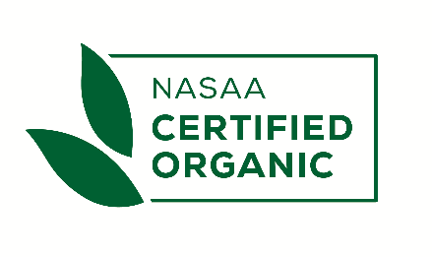 | DEROGATION  REQUEST FORM | CODE  FM_ CERT_Derogation Request
Version 5
Previous: 21/01/2022
Effective: 28/01/2025

NAME OF OPERATOR: |  | CERTIFICATION NUMBER:

REQUESTED DEROGATION LENGTH | START AND END DATE:  Maximum 12 months  or Single Purchase

WHAT DEROGATION ARE YOU APPLYING FOR?
All Derogations are outlined in supplied Annex

PLEASE STATE REASON FOR DEROGATION APPLICATION

All required evidence as outlined in Annex has been attached: yes
Please note: if all required supporting evidence as outlined is
not provided with this form, your request may not be processed. no

NAME: | SIGNATURE:
DATE:

